Combat Design Documentation for Project Pantheon

Table of Contents

Combat Methods 2

Melee 2

The Spear 2

The Sword 3

Range 3

Special 4

# Combat Methods

Combat will occur with three main methods/weapons:

1. Melee
2. Range
3. Special

Combat must be fluid to allow quick intuitive combos and swapping between combat methods to be as fluid as possible

## Melee

Melee will occur within Pantheon with two main weapons:

1. A Spear
2. A Sword

### The Spear

The Spear used in the game is a standard Corinthian Era Long Spear (for more information on the Corinthian Era Spear please consult the associated Research Document)

The Spear will rely on two main attack methods, heavy and light attack combos can occur with a combination of these attacks

Heavy attacks will include the following movements:

* A sweep with the spear that impact the opponent around the midriff
* An overhead downward attack that will contact the opponent either on the head or shoulders that may temporary stun an opponent
* A heavy thrust aimed at the opponent’s chest

Light attacks will be faster than the heavy attacks but do less damage:

* A Variety of low and high thrusts at high speed

#### Spear Animation State Machine

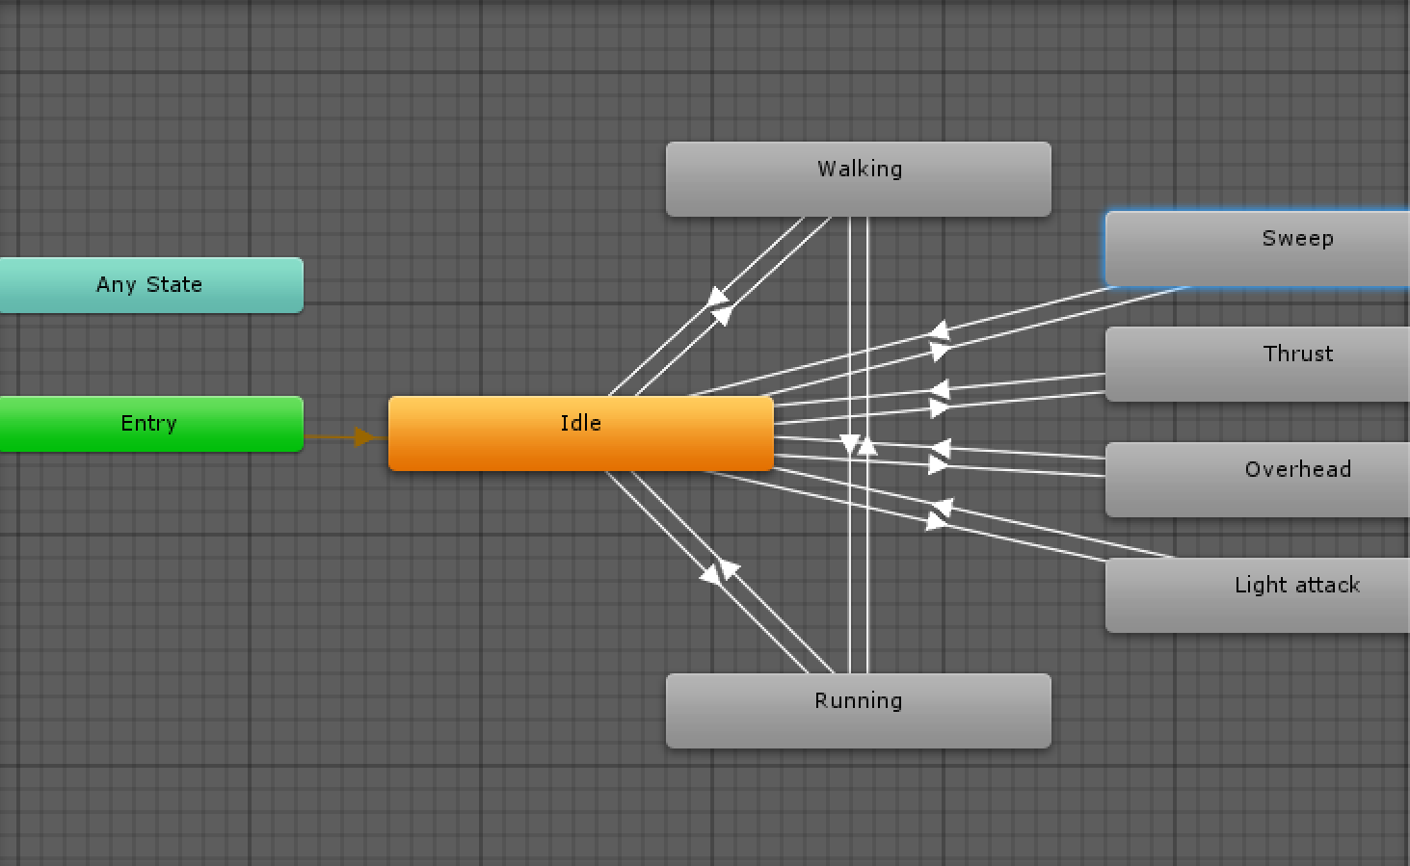

### The Sword

The sword used in the game will be a Kopis Sword which is a Corinthian era short sword (for more information on the Kopis please consult the associated Research Document)

The sword will use only light attacks as it designed to be a secondary weapon like it was in the era of the ancient Greeks and will three different attack variations

* A forward stab
* A downward slash
* A lower body thrust aimed at the guts

#### Sword Animation State Machine

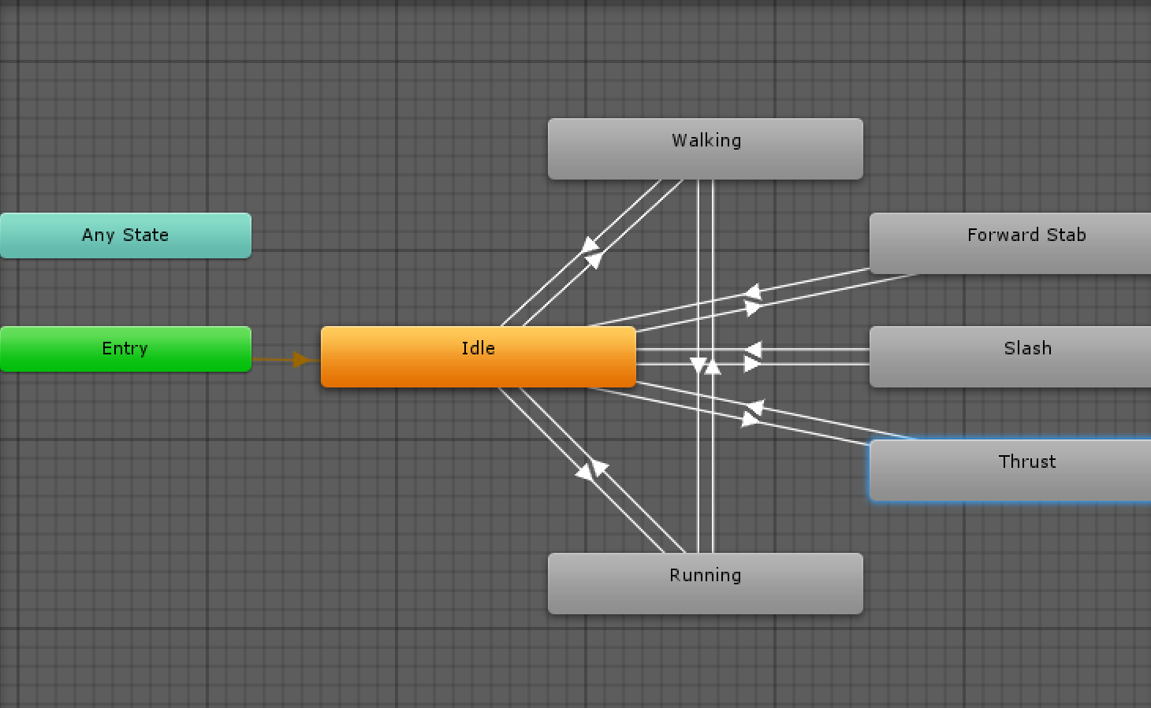

## Range

Range attacks will occur with a bow, the bow will not unlimited ammo but most enemies will drop arrows so the player will end up with an endless amount *The ammo system is subject to change and review*

The range attacks will have a set maximum distance with arrow dipping over time to mimic that of a real bow and arrow.

The time the player holds the down the button to initiate a range attack will influence the force at which the arrow will fire, the longer the hold, the more force. The time will be capped to indicate the bow has been fully extended but not fired until the button has been released.

#### Range Animation State Machine

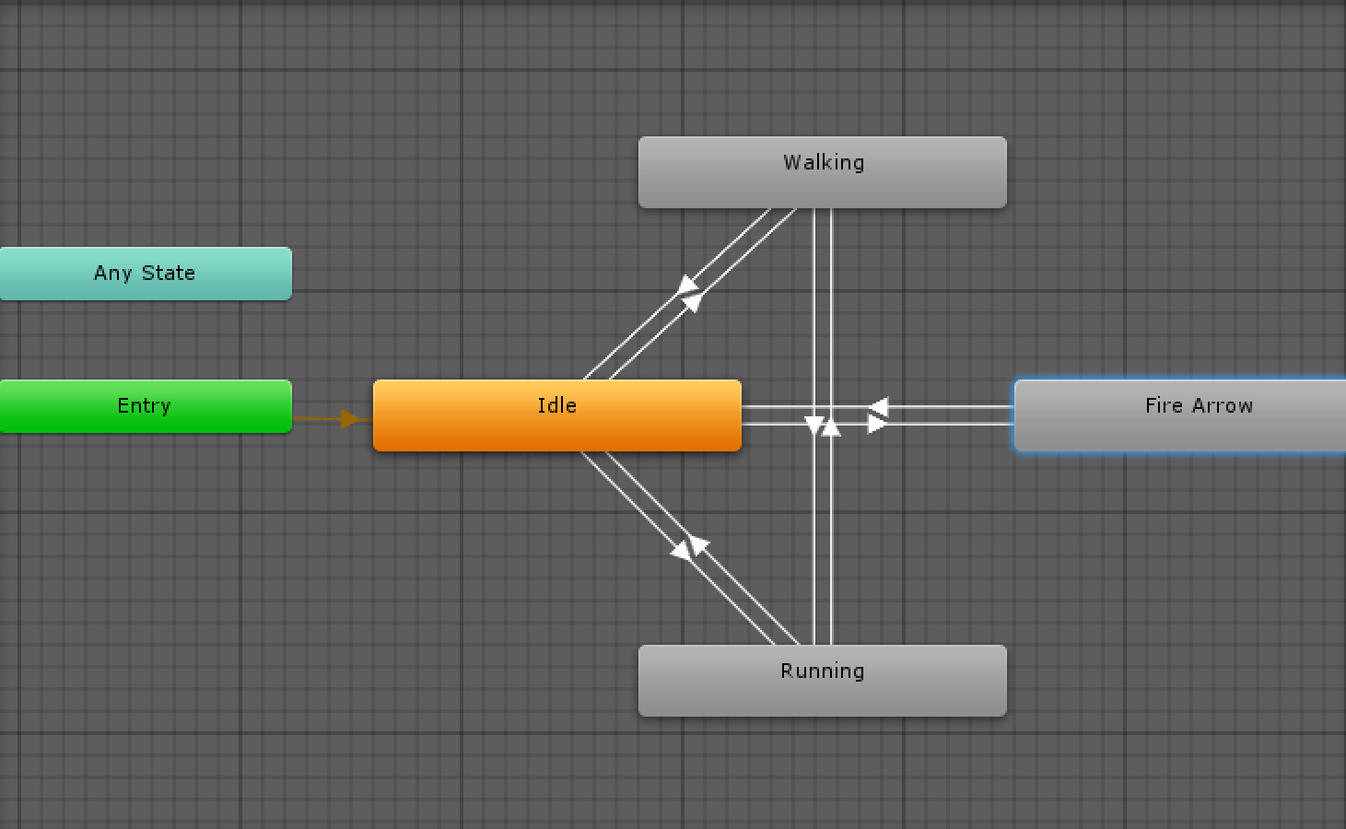

## Special

The special attacks in this game are under the name God Gift’s and they will be obtained by earning the gods favour. Each Gift will perform a different function related to the God’s area of influence. A couple of examples:

|  |  |  |  |
| --- | --- | --- | --- |
| God | God’s Ability | God Gift | Description |
| Hermes | Gods Messenger  (Carries a bow) | Golden Arrow | Allows for unlimited golden arrows to be fired for 30 seconds |
| Persephone | Goddess of Death | Awaken Help | Summons a skeleton that will attack enemies and lasts up to 1 minutes |
| Zeus | God of Thunder | Zeus’s Wrath | Fires a lightning bolt that incinerates any target or does significant damage to a boss, has a minute cool down. |

One god gift may be equipped at each time to allow for a variety play styles  
*this may be changed due to increase gameplay elements*

#### God Gift State Animation

